«Always safe» - a checklist for leaders from the industry collaboration alwayssafe.no
Prevent falling objects – SPOTLIGHT ON scaffolds
Equinor, Vår Energi and Aker BP have established a common annual wheel for important, cyclical topics – including falling objects. This checklist was developed based on inspiration from the SfS handbook to prevent falling objects, as well as actions taken after unwanted incidents and experiences from previous learning packages in the annual wheel.
Context  Scaffolding work and work at height are risky.  A dynamic falling object (FO), is an object falling down due to an external force and poses a significant safety challenge. | Preparation for sampling and spot checks  In order to verify according to this checklist, you will need to consider the following:  - Make a selection of active work permits and check scaffolding and/or work at height.  - When in field, have at hand the SFS handbook to prevent falling objects into the field, as it contains illustrations of best practices.

# | Assessments | Observation and Action Description
1 | Scaffolding log  Go to the scaffolding foreman – or gain access to the scaffolding log – and ensure it gives a satisfying picture of the status.  Checkpoints  - Are all scaffoldings in the log checked and re-checked according to the required inspection interval?  - Are scaffoldings that are exposed to rough weather marked in the scaffolding log?
2 | Condition of scaffolds in the field  Select a number of scaffolds from the scaffold log and perform a field survey – either alone or with the scaffolding foreman.  Checkpoints  - Do scaffolds in use have a green tag indicating the dates of check and re-check?  - After a storm; is scaffolding re-checked before being used?  - Do any of the scaffoldings have visible defects/damages?  - Are kicking boards mounted?  - Do scaffolding boards in weather exposed scaffolding have double lashing, as recommended by best practice after investigations (see photos below)?  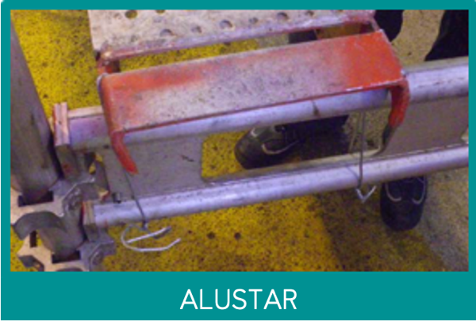  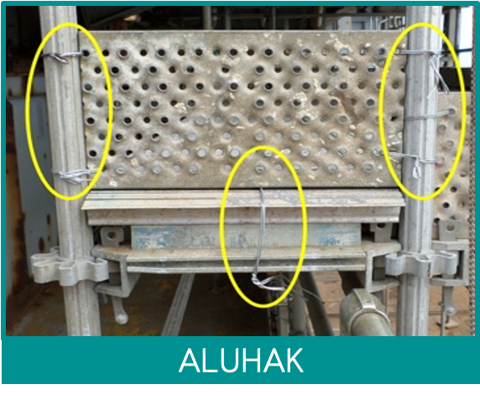
3 | Users of scaffolding  If you come across users of scaffolding in the field during the inspection, check the users knowledge of scaffolding.  Checkpoints  - Does the user know when the scaffold was last checked/re-checked – and does the user know when they cannot use the scaffold?  - Has the user completed a course for scaffolding?  - Does the user know which weight limitations apply for the scaffold?  - Are there openings in the scaffold that should be closed with nets or cuffs?  - Is there work nearby (above/below) that poses a risk to the user or to others?  - Have the proper barriers been set up below the scaffold for the ongoing work on the scaffold?
4 | Building and disassembling scaffolds  Based on current scaffolding work permits, conduct a field survey for selected scaffolding jobs. If possible, bring the scaffolding foreman.  Checkpoints  - Do the executing scaffold builders have the necessary competence?  - Is the correct fall protection equipment used when working at height?  - Are tools and loose objects sufficiently secured?  - Are scaffolding and tarpaulin secured for wind conditions?  - Could scaffolding being built come in conflict with lifts/cranes/sliding doors or similar?  - Is the scaffolding considered to be weather exposed? If yes; is scaffolding plank being secured extra well?  - For disassembly of scaffolding: Are all loose parts (potential falling objects) on scaffolding equipment removed before starting to lift/transport equipment?

Performed by | Date | Installation | Synergi reference

