«Always Safe» - a checklist for leaders from the industry collaboration alwayssafe.no
prevent falling objects: finding objects before they fall
Equinor, Vår Energi and Aker BP have established a common annual wheel for important, cyclical topics – including falling objects. This checklist was developed based on inspiration from the SfS handbook to prevent falling objects, as well as actions taken after unwanted incidents, and experiences from previous learning packages in the annual wheel.
Context  A static falling object (FO), is an object falling down without external force other than wind, vibrations, etc., and poses a significant safety challenge. | Preparation for sampling and spot checks  In order to verify according to this checklist, you will need to consider the following:  - Decide beforehand in which physical areas to perform the verification  - Be clear about what types of objects you mainly will be looking for  - Together we see better, so if possible, perform the verification in pairs/groups  - Remember to check that maintenance programs are being followed

# | Assessments | Observation | Action description
1 | Fastening and securing floodlights, PA speakers, etc.  Inadequate secondary protection of floodlights presents a high risk, as these floodlights are often large and heavy, and placed high above and close to areas where personnel are present.  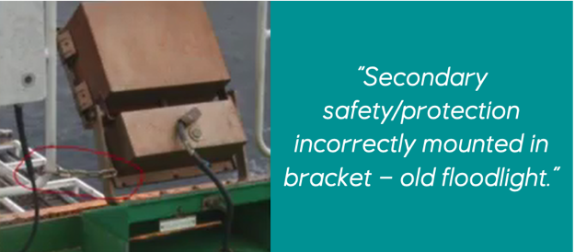  Checkpoints  - Is the secondary protection mounted correctly, and fastened to the object that may fall? There have been examples of protection being fastened to the object falling down and not fulfilling the requirement for secondary protection.  - Are carabiner hooks used in securing/protection in good condition?  - Do you find the use of acid resistant wire with aluminum clamping sleeve as security/protection wire?  - Have plastic strips been used for temporary securing of floodlights in for example scaffolding?  - Do you find unsecured floodlights and/or PA speakers in field?
2 | Equipment removed from use  Equipment that is to be removed from use is sometimes not removed as planned - and parts of the equipment remain as potential sources of falling objects in the future. Perform a survey in areas where you know that equipment has been taken out of use.  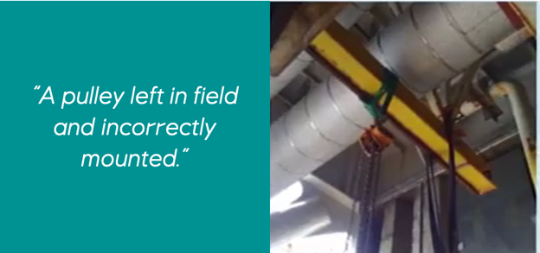  Checkpoints  - Do you find any leftover equipment remaining in field after the equipment installation has been taken out of use and removed?
3 | Poor fastening of signs  Poor fastening of signs sometimes occur and signs are often exposed to rough weather. There have been cases where, in order to avoid galvanic corrosion, some signs have been glued on using, for example, Tech7. Glue is not a good solution. Carry out an inspection of signs on the installation.  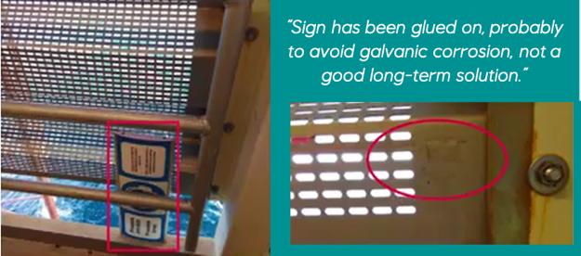  Checkpoints  - Do you find signs that are only glued on?  - Do you find sub-dimensioned fasteners for signs that have to withstand relatively large wind forces and/or vibrations?
4 | Galvanic corrosion  This is one of the sources of falling objects that is most difficult to see in the field, and therefore requires that you work accurately and know the voltage range as the basis for galvanic corrosion. It is recommended that you watch the following 5 minute video: About galvanic corrosion. (Hold down the "CTRL button" and then click the link).  Checkpoints  - Do you find sign fastenings that are subject to galvanic corrosion?  - Do you find brackets in the field for floodlights, PA speakers etc., with incipient galvanic corrosion?  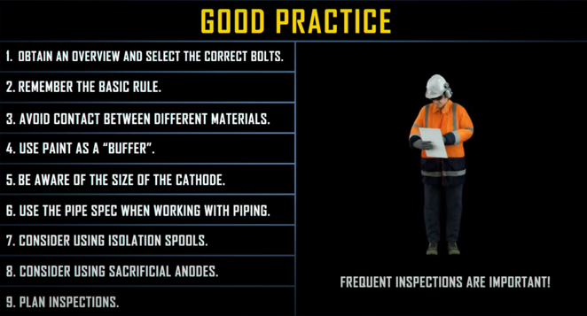
5 | Forgotten lifting equipment and lifting equipment removed from use  Perform an inspection to check that typical sources of falling objects within lifting equipment revealed in Q3 2019 do not reappear.  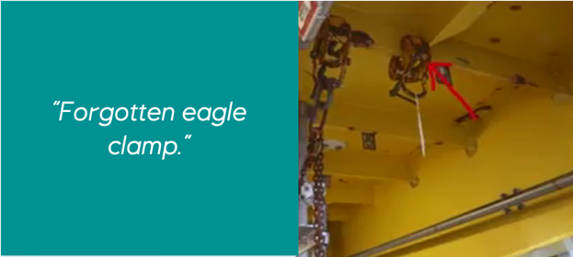  Checkpoints  - Check the rig ceiling for the equipment that has been signed out the longest.  - Is there any forgotten temporary lifting equipment, such as hoists, shackles and/or eagle clamps suspended in the field?
6 | Securing of tools and forgotten tools in the field  Experience shows that a relatively large proportion of falling objects are due to hand tools that have been forgotten in the field after the work is completed. Select an area of the facility/installation/site from the work permit log, where there has recently been done work with hand tools, and perform an inspection.  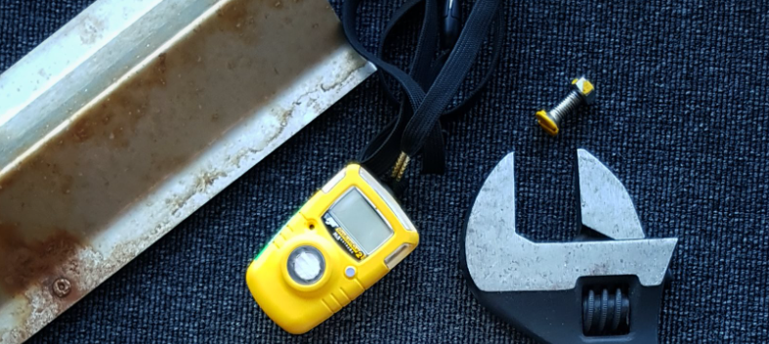  Checkpoints  - Do you find forgotten equipment in the area?  - Is the fall arrester equipment for securing tools used for working aloft; intact and fully functional? Remember that home-made protection equipment is not OK.
7 | Loose objects on top of cargo carriers / containers  Perform an inspection of cargo carriers / containers. In recent years, the industry has experienced that loose items may be left on top of containers, e.g. scaffolding parts, rust flakes, tools and other objects that may fall down when containers are being moved.  Checkpoints  - Are all cargo carriers / containers free of loose objects?
8 | Checking scaffolding stock and shelves for equipment storage  Most facilities/installations/sites have a local practice for storage of equipment in the field, whether these are formal storages or other areas used for storage but not designed for such. It is important to check both that the tools and parts stored in shelves are stored properly, and that shelves built in situ are secured in order to prevent falling objects.  Checkpoints  - Are the shelves and storage units you inspect designed so that equipment cannot inadvertently fall to the underlying level?  - And just as important; are the shelving and storage units themselves secured and fastened to the structure in a safe manner?
9 | Checking lids, hatches and hinged connections  Lids and other similar objects are potential falling objects due to improper use, lack of inspection/maintenance and general lack of vigilance.  Checkpoints  - Are the lids/hatches you selected for inspection properly positioned and secured against falling?  - Do hinges, fasteners, locks, etc. have a robust condition? (Check for corrosion and abnormal wear.)  - Are the maintenance programs for the hatches you are inspecting being followed?
10 | Checking monorails with end stoppers and trolley  Over the years there have been unwanted incidents where end stoppers have either fallen off and/or have not been mounted properly. Perform a field inspection of a selection of monorails.  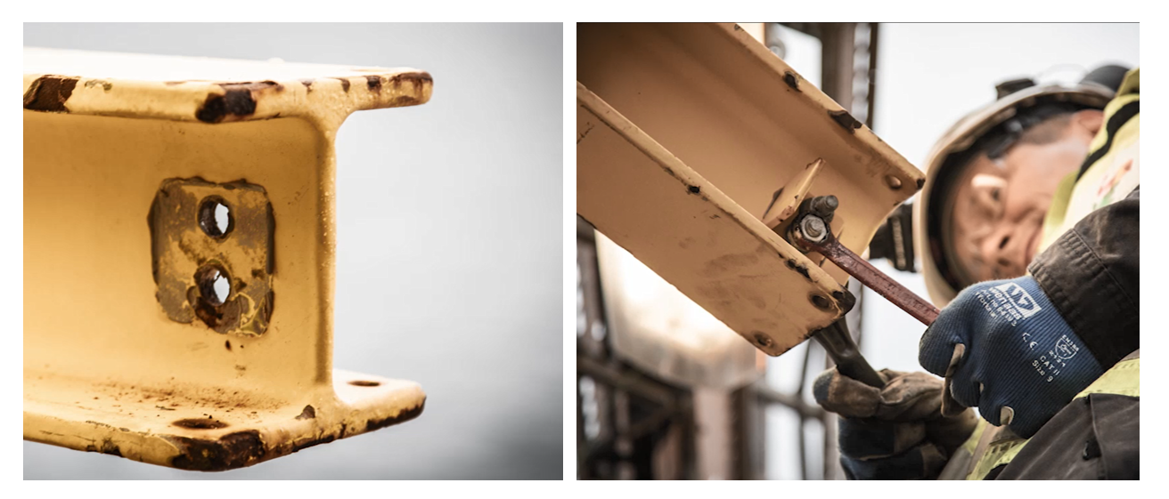  Checkpoints  - Are the end stoppers on the monorails you verify intact, and are the bolts on the end stoppers tightened properly?  - Is the trolley operated with prolonged horizontal force towards the end stoppers? To avoid strain on the end stoppers, skewing when using trolley should be avoided, as knocks against the end stoppers can lead to ruptures in the fastening bolts and the trolley may fall down.  - Have the maintenance routines for checking the end stoppers been followed? Write down the tags for the monorails you verify and cross check in the maintenance system.

performed by | Date | Installation | Synergi reference

Evaluation of checklist

Do YOU have any suggestions for how to improve this checklist? Write it down here:
E.g. If anything is missing or unclear etc., in the checkpoints above.
Remember to send in your improvement suggestions via the form at www.alwayssafe.no

